Advanced, sustainable IT infrastructure at the Lefdal Mine Data Centre
Rittal receives Data Centre Team Excellence Award 2024
Herborn, 2024-09-05.
At the Data Cloud Conference in Cannes, Rittal was presented with the “Data Centre Team Excellence Award 2024”. The award recognises the achievements of the Rittal team at the Lefal Mine Data Centre (LMD) in Norway. This includes consultancy and the holistic approach of the RiMatrix containerised platform and Fjord water cooling solution, covering all the pillars of the data centre infrastructure – modularity, standardisation and scalability.
Operated in a former mine, the Lefdal Mine Datacenter is one of the most secure, flexible and energy-efficient data centres in Europe. Norway has a large local surplus of low-cost electricity from renewable energy. Cold fjord water is used for cooling. The data centre offers low project and operating costs, natural EMP security, high scalability and flexibility, and is highly energy efficient with a PUE of less than 1.1.
Rittal is playing a key role in the implementation and operation of this state-of-the-art data centre. The “Data Centre Team Excellence Award 2024” recognises projects that, according to the jury’s criteria, “have had a major impact on the data centre and cloud services sector in the past 18 months”.
Energy-efficient cooling and comprehensive IT infrastructure management
Based on the RiMatrix portfolio, Rittal has designed standardised and containerised data centre solutions for the LMD that offer great flexibility and cost efficiency. These pre-configured modules are installed in turnkey containers and have up to ten racks. They are equipped with power distribution and climate control as well as with monitoring software for end-to-end IT infrastructure management. From colocation and private cloud to ITaaS (IT as a service) and DCaaS (data centre as a service), this enables the rapidly scalable deployment of IT systems.
In addition, the Rittal team has introduced a climate control solution with the Liquid Cooling Package (LCP) range. The LCP directs the hot air from the servers through a special heat exchanger connected to the Fjord’s 7°C chilled water circuit, efficiently cooling the hot air to the desired inlet temperature of 15°C before returning it to the system. This process leads to a Power Usage Effectiveness (PUE) of less than 1.1. With 97 per cent of its electricity coming from renewable sources, the low power consumption is not only economical but also climate-friendly.
Anna Klaft, Vice President IT Business Unit at Rittal and member of the Board of Directors of Ledfal Mine explains: “This award from a prestigious jury is a great recognition for us. I am very happy for our team, because this award shows how expertise and a clear view of users’ needs on the one hand and the flexibility of standardised modules on the other complement each other and play to their strengths for the customer.
Megawatt cooling with water
Rittal also gave a preview of its next technological innovation at the “Data Cloud Conference”: Single-phase direct liquid cooling with water as an indispensable “enabler” for AI applications. The reason is simple: The required power density pushes the air cooling in the rack to its limits. Working closely with several hyperscalers and server OEMs, Rittal has developed a new type of Coolant Distribution Unit (CDU) with a cooling output greater than 1 MW. It fits compactly into a bayed OCP rack and its modular design means it can be easily serviced while running.

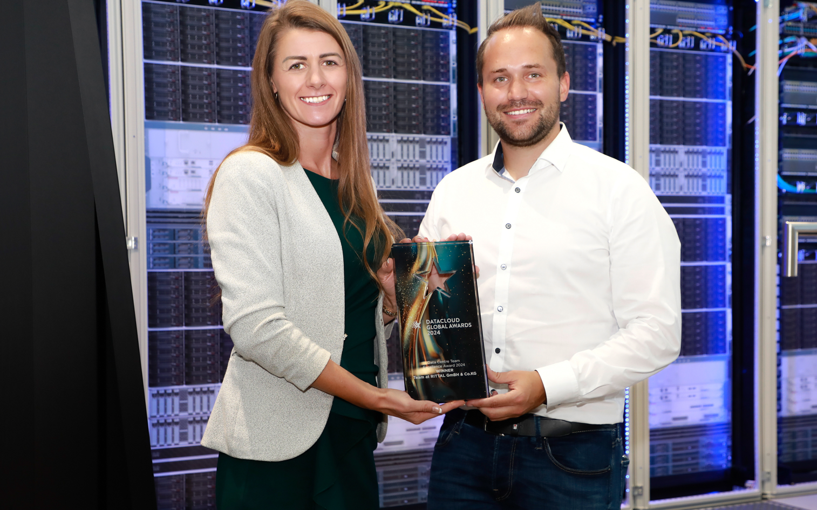
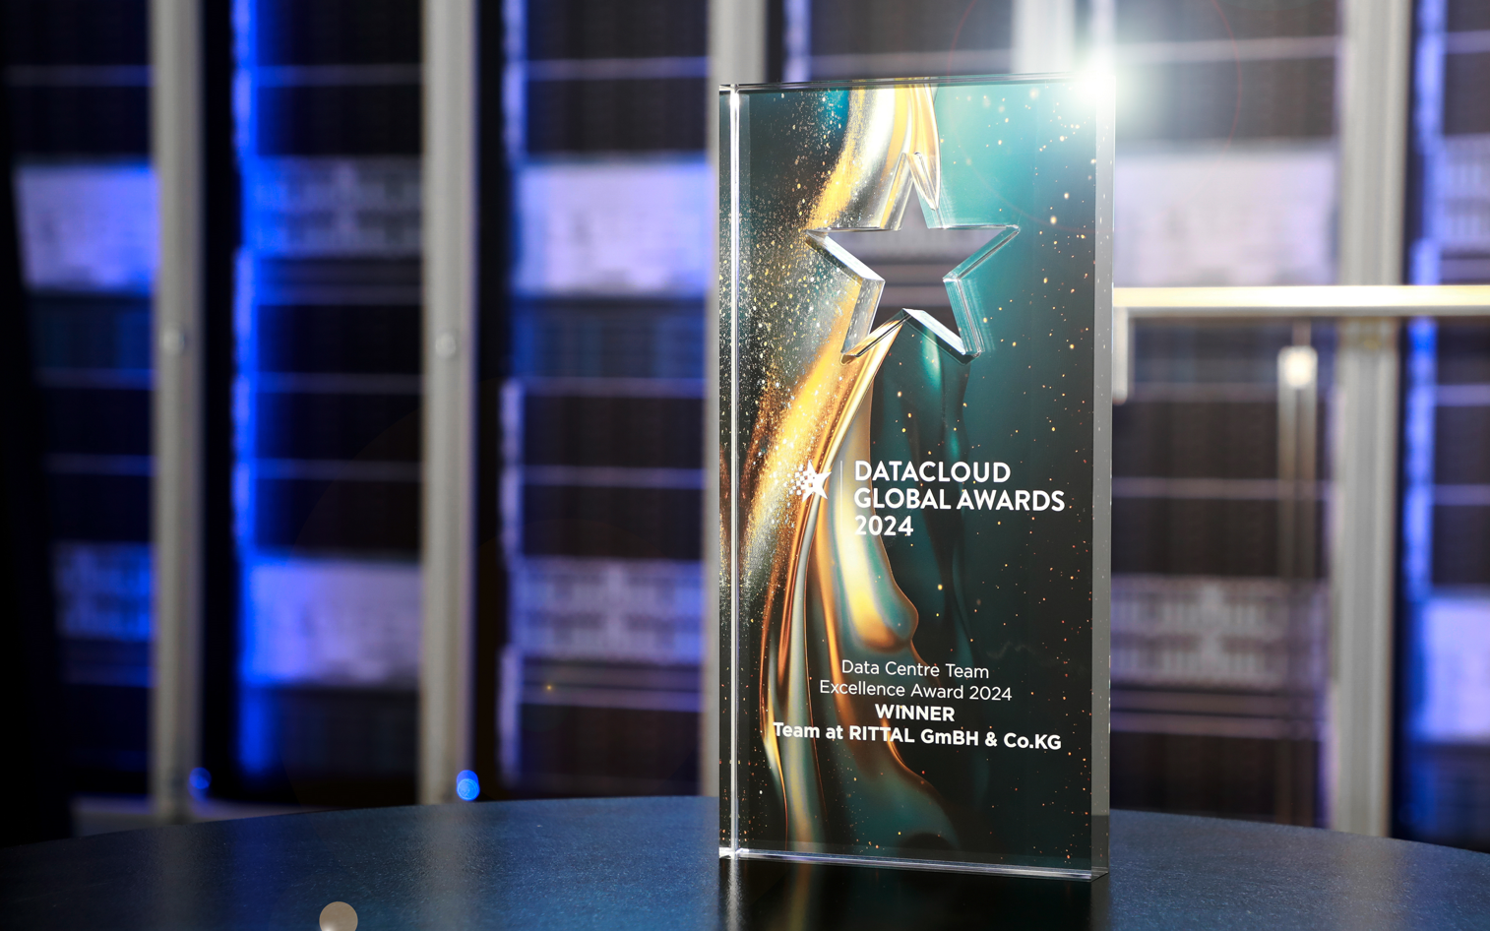

Image 1  Anna Klaft, Vice President IT Business Unit at Rittal and member of the Board of Directors of Ledfal Mine: “This award from a prestigious jury is a great recognition for us.” |  | Image 2  The “Data Centre Team Excellence Award 2024” recognises projects that, according to the jury’s criteria, “have had a major impact on the data centre and cloud services sector in the past 18 months”.

May be reproduced free of charge. Please name Rittal GmbH & Co. KG as the source.

Rittal

Rittal is a leading global supplier of enclosure systems, automation and infrastructure with its industrial, IT, energy and power, cooling and service units. Rittal products and solutions are used in over 90% of global industries – standardised, customised, and always of the very best quality.
Our approach and methodology: Rittal, Rittal Software Systems (Eplan, Cideon and German Edge Cloud) and Rittal Automation Systems (RAS, Ehrt, Alfra) combine their hardware and software expertise to streamline, optimise and digitalise processes across the entire value chain for our customers including their IT infrastructure – from control and switchgear construction, machine building to factory operators or the energy sector.
Our delivery promise: Rittal standard products are delivered in Germany within 24 hours, and within 48 hours throughout Europe.
Customer focus
Improving efficiency and increasing productivity through automation and digitalisation is one of the biggest challenges for our customers. This requires in-depth knowledge and expertise, the combination of hardware and software, and cross-sector networking. We are convinced that creating and connecting data rooms is crucial to the success of industrial transformation. And that is exactly our speciality and field of competence.
Eplan and Rittal are driving the development of the digital automation twin, making data accessible and useable in operations as well. Cideon is improving data consistency in the digital product twin context with its CAD/CAM, PDM/PLM and product configuration expertise. German Edge Cloud’s ONCITE Digital Production System (DPS) makes production process data transparent, enabling it to be optimised – right through to energy management using digital production twins.
Sustainability
Environmental and climate protection, social commitment and ethical corporate management are a given for Rittal. We take our responsibility for a sustainable future seriously. Our approach to resource management and conservation involves continuous improvement of our own production processes and ensuring that our products have the lowest possible Product Carbon Footprint. Our solutions support our customers in achieving their own climate targets.
Family business and global player
Founded in 1961, Rittal is the largest company in the owner-operated Friedhelm Loh Group. The group operates worldwide, with more than 12 production sites and over 95 international subsidiaries. It has more than 12,100 employees and posted revenues of 3 billion euros in fiscal 2023. In 2023, the Friedhelm Loh Group was presented with the “Best Place to Learn” and “Employer of the Future” awards. In 2024, Rittal was awarded the Top 100 Seal as one of Germany’s most innovative medium-sized companies for the third time in a row.
For more information, visit www.rittal.com and www.friedhelm-loh-group.com.

Corporate Communications
Dr. Carola Hilbrand Rittal GmbH & Co. KG
Corporate & Brand Communications Auf dem Stützelberg
Tel.: 02772/505-2527 35745 Herborn
hilbrand.c@rittal.de www.rittal.com


Follow us:

